Year 7’s and the Beanstalk - A Scientific Investigation

This is to be completed as a group BUT you all need
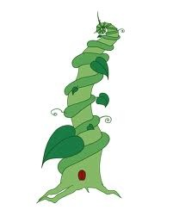
a copy

The Planning

- What is your research question? What do you want to find out? What ‘one thing’ do you want to change to see what effect it has on some ‘other thing’ ?

2. What is the one thing you are going to change? ( see the table at the bottom of this document)

3. What thing are you going to measure? ( see the table at the bottom of this document)

4.What other variables are there to keep the same? How can you keep them the same?

5.How can you make sure that the investigation is fair and not a ‘fluke’ or mistake?

6. What is your prediction as to what the answer to your research question might be?

7. What materials and equipment do you need for your investigation?

8. What are you going to do in your investigation? What steps are you going to follow?

2.
3.
4.

9. What are you going to record and how are you going to record it?

Example of investigation planning
RESEARCH QUESTION: WHAT IS THE EFFECT OF DIFFERENT CONCENTRATIONS OF SALT ON BEAN GERMINATION?
Independent variable: different concentrations of salt

Dependent variable: bean germination

Controlled variables: for example, types, ages and size of beans, type of salt, temperature, intensity and colour of light, volume of solution added
Control: set-up that had everything the same, but used water with no salt. This could be used as a baseline for control to see whether the addition of salt had an effect on bean germination.

Sample size: using 10 bean seeds instead of one seed in each set-up and using class results to increase the number of times that the investigation was performed.

What you are measuring
What you are changing
